

SIMATS ENGINEERING

Saveetha Institute of Medical and Technical Sciences Chennai- 602105
Student Name: ABHINAY ADITHYA Reg. No.:
Course Code: CSA 0202 Slot:C
Course Name: C PROGRAMING
Course Faculty: DR.V.JAYASUDHA

Project Title: ELECTRICITY THEFT DETECTION AND BILLING ANOMALY SYSTEM
Module Photographs: (3 photographs –Module Photo, Individual student contribution module work in the project and presentation image)
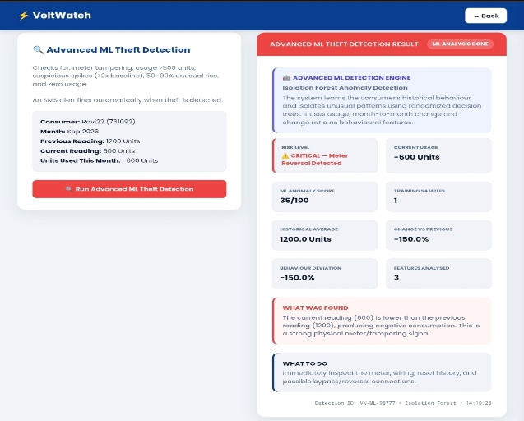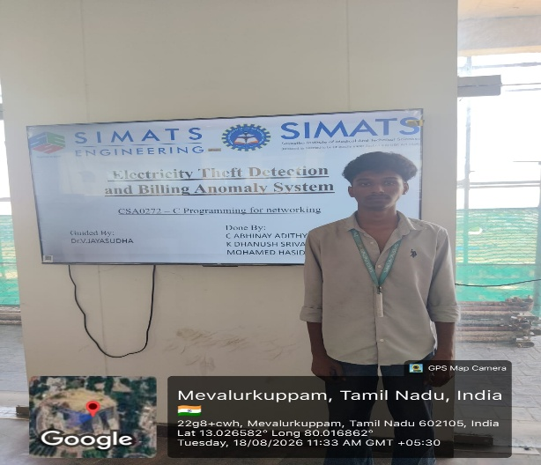
Project Description: a smart system that monitors customer details and meter readings to identify abnormal consumption, billing errors, and possible electricity theft.
MODULE 2:
Purpose:
To analyze meter readings and identify unusual consumption patterns, possible meter bypass, and illegal electricity connections.
Functions:
- Spike Detection: Identifies unusually high electricity consumption.
- Drop Detection: Detects zero or very low consumption that may indicate meter bypass or tampering.
- Usage Comparison: Compares current consumption with the customer's normal/average usage.
- Illegal Tap Detection: Compares transformer load with the total recorded consumer usage.
- Risk Classification: Assigns a risk level such as LOW, MEDIUM, HIGH, or CRITICAL.
- Alert Generation: Generates an alert when suspicious consumption patterns are detected.

Student Signature Guide Signature

